Source Code:
WEB-FORM
<%@ Page Language="C#" AutoEventWireup="true" CodeBehind="WebForm1.aspx.cs" Inherits="Tech.WebForm1" %>

<!DOCTYPE html>
<html lang="en" xmlns="http://www.w3.org/1999/xhtml">
<head runat="server">
<meta charset="utf-8" />
<title>Technology Faculty</title>
</head>
<body>
<form id="form1" runat="server">
<div>
<asp:CheckBoxList runat="server" ID="CheckBoxList1" OnSelectedIndexChanged="CheckBoxList1_SelectedIndexChanged">
<asp:ListItem Text="1. Infromation Technology" Value ="1"></asp:ListItem>
<asp:ListItem Text="2. Computer Science" Value ="2"></asp:ListItem>
<asp:ListItem Text="3. Computer Engineering" Value ="1"></asp:ListItem>

</asp:CheckBoxList>
<asp:Button ID="Button1" runat="server" Text="Details >>" OnClick="Button1_Click" />
</div>
</form>
</body>
</html>

C# CODE.
using System;
using System.Collections.Generic;
using System.Linq;
using System.Web;
using System.Web.UI;
using System.Web.UI.WebControls;

namespace Tech
{
public partial class WebForm1 : System.Web.UI.Page
{
protected void Page_Load(object sender, EventArgs e)
{

}

protected void CheckBoxList1_SelectedIndexChanged(object sender, EventArgs e)
{

}

protected void Button1_Click(object sender, EventArgs e)
{
foreach (ListItem li in CheckBoxList1.Items)
{
if (li.Selected)
{
if (li.Value == "1")
{
Response.Write("<h3> Information Technology. </h3>");
Response.Write("<hr>");
Response.Write("<p> Infromation Technology. \n Information technology (IT) is the use of computers to store, retrieve, transmit, and manipulate data,[1] or information, often in the context of a business or other enterprise.[2] IT is considered to be a subset of information and communications technology (ICT). An information technology system (IT system) is generally an information system, a communications system or, more specifically speaking, a computer system – including all hardware, software and peripheral equipment – operated by a limited group of users.</p>");
Response.Write("<br>");
Response.Write("<hr>");
}
else if (li.Value == "2")
{
Response.Write("<h3> Computer Science. </h3>");
Response.Write("<hr>");
Response.Write("<br>");
Response.Write("<p> Computer Science. \n Computer science (sometimes called computation science or computing science, but not to be confused with computational science or software engineering) is the study of processes that interact with data and that can be represented as data in the form of programs. It enables the use of algorithms to manipulate, store, and communicate digital information. A computer scientist studies the theory of computation and the practice of designing software systems.</p>");
Response.Write("<br>");
Response.Write("<hr>");
}
else if (li.Value == "3")
{
Response.Write("<h3> Computer Engineering. </h3>");
Response.Write("<hr>");
Response.Write("<br>");
Response.Write("<p>Computer Engineering. \n Computer engineering is a branch of engineering that integrates several fields of computer science and electronic engineering required to develop computer hardware and software.[1] Computer engineers usually have training in electronic engineering (or electrical engineering), software design, and hardware-software integration instead of only software engineering or electronic engineering. Computer engineers are involved in many hardware and software aspects of computing, from the design of individual microcontrollers, microprocessors, personal computers, and supercomputers, to circuit design. This field of engineering not only focuses on how computer systems themselves work but also how they integrate into the larger picture.</p>");
Response.Write("<br>");
Response.Write("<hr>");
}
else
{
Response.Write("Multiple Item Selected or None, Please Select One Item at a Time");
}

//Response.Write("Text =" +

}
}

}
}
}

SCREENSHOTS
CASE 1: INFORMATION TECHNOLOGY.
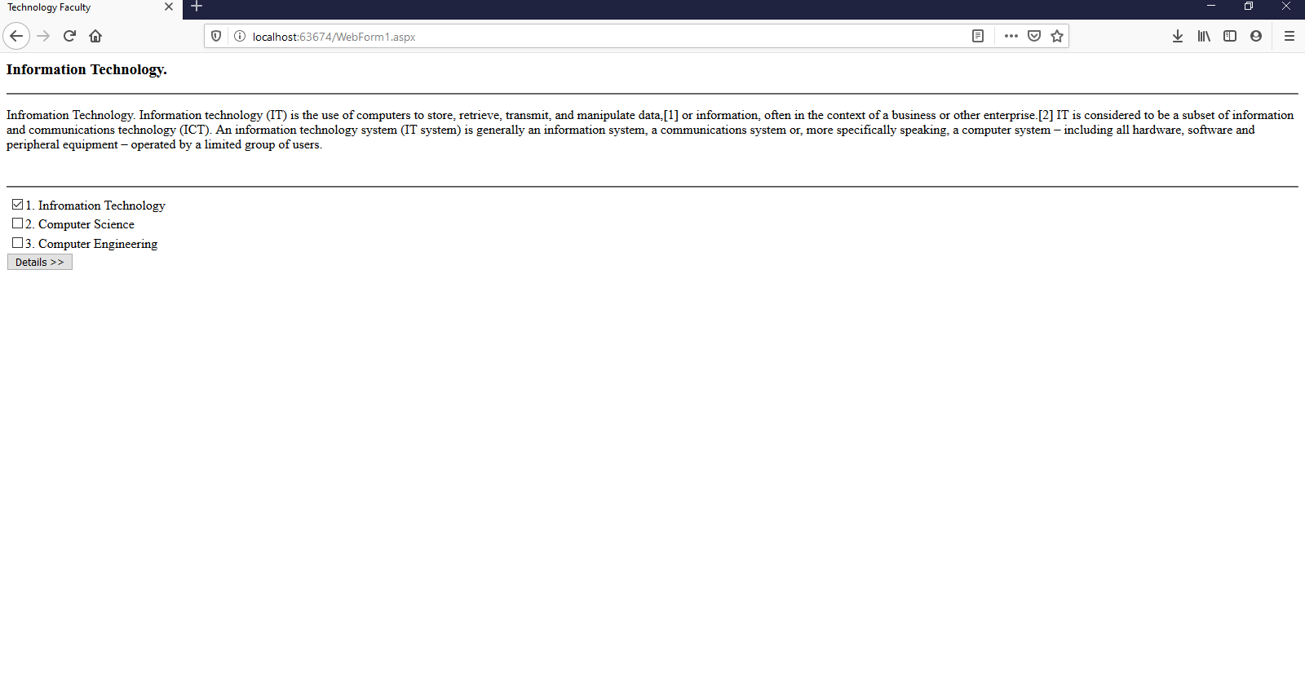

CASE 2: COMPUTER SCIENCE
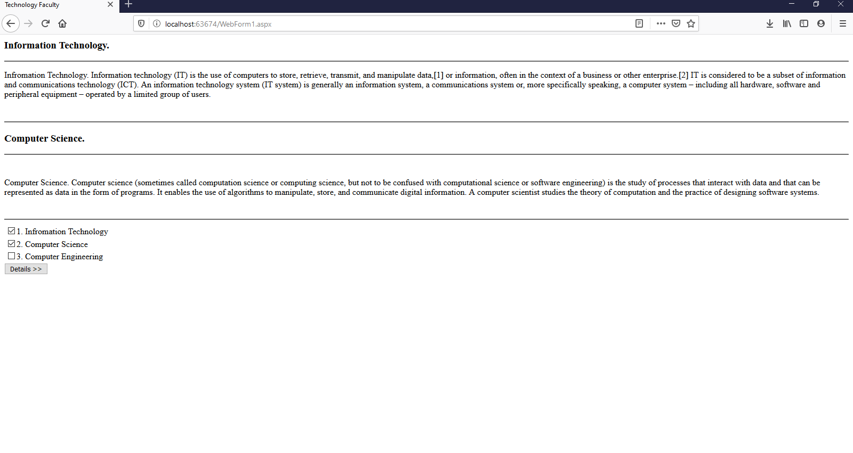

CASE 3: COMPUTER ENGINEERING.
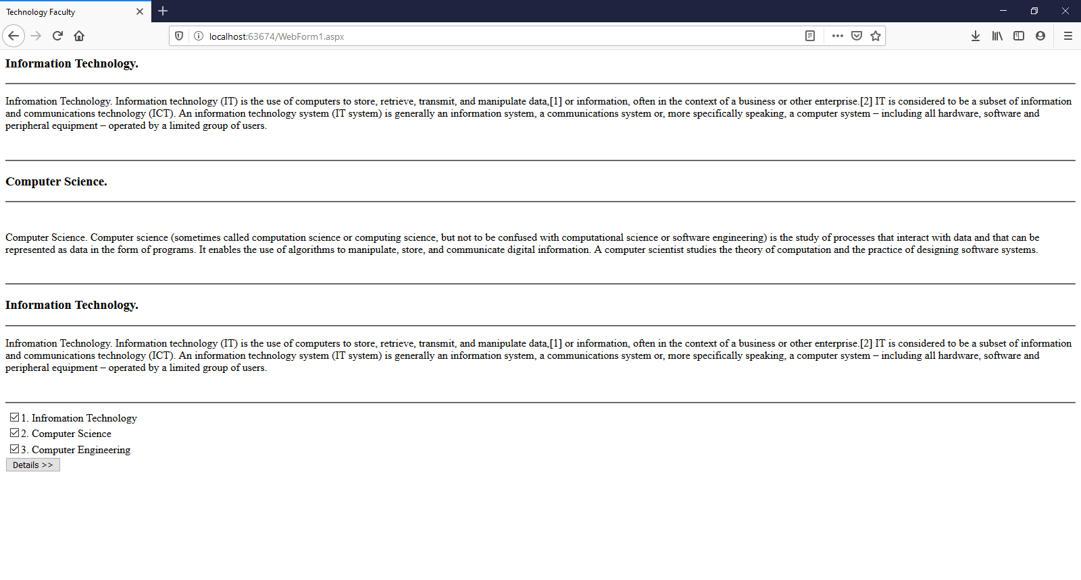

CASE 4: HOME PAGE.


